

PROJECT
Of
“R PROGRAMMING”
(25CAP-161)

Submitted By:
NAME : SHREYA SUMAN
UID: 25BCD10188
BRANCH : COMPUTING
GROUP: BCD-1
SECTION: B
SEMESTER: SECOND

Submitted To:
NAME: MISS SUSHMA
DESIGINATION: ASSISTANT PROFESSOR

University Institute of Computing
Chandigarh University, Gharuan, Mohali

MINI PROJECT TOPIC

🎵MUSIC RECOMMENDATION SYSTEM USING R🎵

INDEX

S. No. | 📖 CONTENTS | 📄 PAGE NO.
01 | 🧾 INTRODUCTION | 01
02 | 🎯 OBJECTIVES | 02
03 | 📊 DATA DESCRIPTION | 03
04 | 🛠️ TOOLS & TECHNOLOGIES | 04
05 | 💻 CODE AND EXPLANATION | 05-19
06 | 📈 OUTPUT (GRAPHS & RESULTS) | 20-22
07 | 📌 CONCLUSION | 23
08  09 | 🎓 LEARNING OUTCOMES  GIT HUB LINK | 24  25

INTRODUCTION
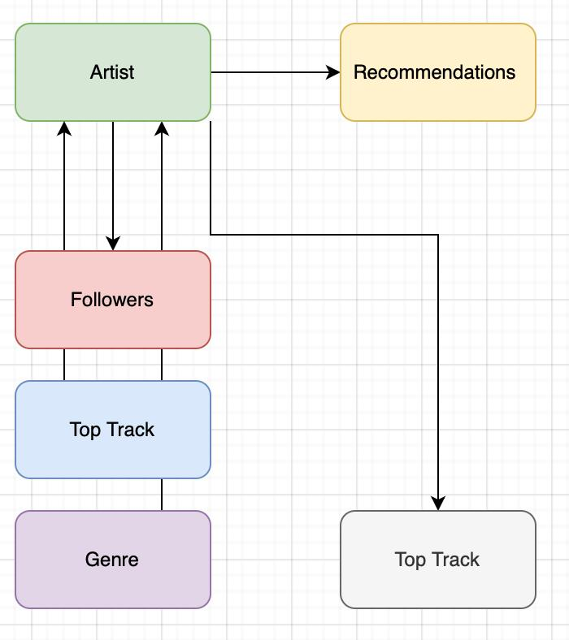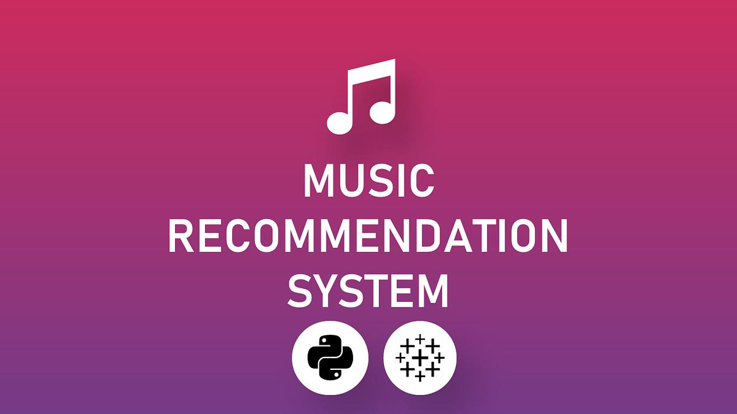

Music is one of the most powerful forms of art and communication. It has the ability to influence emotions, improve mood, reduce stress, and even enhance productivity. In today’s digital age, people have access to millions of songs through various online platforms such as music streaming services. While this vast collection provides variety, it also creates a challenge: how to find the right song at the right time.
Different people prefer different types of music based on their mood, situation, and personal taste. For example:
- A person may prefer energetic music while working out
- Calm or soft music while studying or relaxing
- Sad songs during emotional moments
- Happy songs during celebrations
In this project, we develop a basic Music Recommendation System using R programming. The system uses a dataset of songs and analyzes different attributes such as:
- Mood
- Tempo (speed of song)
- Energy level (intensity of song)
- Popularity
Based on these attributes, the system provides song recommendations when the user inputs a specific mood. For example, if the user enters “Happy”, the system will display all songs categorized under the “Happy” mood along with their details.
It also introduces students to real-world applications of data science in a simple and easy-to-understand manner.

OBJECTIVES

The objectives of this project are:
- To learn and understand the basics of R programming
- To develop skills in creating and managing datasets using data frames
- To analyze song data based on different attributes such as mood, tempo, energy, and popularity
- To perform operations like sorting, filtering, and aggregation
- To create meaningful visualizations using bar charts
- To understand how recommendation systems work
- To build a simple interactive system that takes user input
- To improve logical thinking and problem-solving skills
- To apply theoretical knowledge to a real-life application
- To prepare students for advanced topics like machine learning and data science

DATA DESCRIPTION
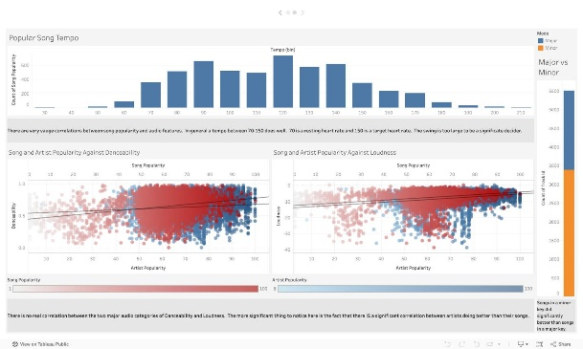
The dataset used in this project is a small, structured dataset created manually. It contains 18 songs from different artists and genres to demonstrate how data can be analyzed.

🔹 Detailed Attributes Explanation
- Title
  - Represents the name of the song
  - Used to identify each record uniquely
- Artist
  - Name of the singer or band
  - Helps in analyzing artist frequency
- Mood
  - Categorizes songs based on emotional feeling
  - Examples: Happy, Sad, Energetic, Calm, Chill, Motivational, Epic
- Tempo (BPM)
  - Measures speed of the song
  - High tempo → fast songs
  - Low tempo → slow songs
- Energy
  - Indicates intensity or power of the song
  - Scale: 0 (low) to 100 (high)
- Popularity
  - Indicates how popular or trending a song is

TOOLS AND TECHNOLOGIES

- Programming Language: R
- Library Used: ggplot2
- Software: RStudio
- System Requirement: Basic computer with R installed

🔹 Concepts Used
- Data Frames (tabular data storage)
- Indexing and Subsetting
- Aggregation (aggregate() function)
- Sorting (order() function)
- Conditional Statements (if-else)
- Loops (for loop)
- Functions (custom functions for recommendation system)
- Data Visualization (bar plots, comparison charts)
- User Input (readline() function)

CODE

# Load required packages
library(ggplot2)

# Create music database
songs <- data.frame(
title = c(
"Blinding Lights", "Stay", "Levitating",
"Bohemian Rhapsody", "Imagine", "Let It Be",
"Lose Yourself", "Sicko Mode", "God's Plan",
"Shape of You", "Despacito", "Dance Monkey",
"Someone Like You", "Hello", "Rolling in the Deep",
"Happier", "Wake Me Up", "Counting Stars"
),
artist = c(
"The Weeknd", "The Kid LAROI", "Dua Lipa",
"Queen", "John Lennon", "The Beatles",
"Eminem", "Travis Scott", "Drake",
"Ed Sheeran", "Luis Fonsi", "Tones and I",
"Adele", "Adele", "Adele",
"Marshmello", "Avicii", "OneRepublic"
),
mood = c(
"Energetic", "Chill", "Happy",
"Epic", "Calm", "Calm",
"Motivational", "Energetic", "Chill",
"Happy", "Happy", "Energetic",
"Sad", "Sad", "Energetic",
"Happy", "Motivational", "Motivational"
),
tempo = c(171, 170, 103, 72, 75, 140, 85, 155, 77, 96, 89, 98, 67, 79, 105, 92, 124, 122),
energy = c(85, 65, 88, 70, 40, 60, 92, 95, 70, 83, 78, 82, 45, 55, 87, 75, 80, 78),
popularity = c(95, 92, 89, 98, 85, 88, 94, 90, 87, 96, 93, 84, 91, 90, 89, 86, 88, 87)
)

# Display database
cat("\nMUSIC DATABASE \n")
print(head(songs, 5))

# ============================================
# BAR CHART 1: Songs by Mood Distribution
# ============================================

mood_counts <- table(songs$mood)
barplot(mood_counts,
main = "Number of Songs by Mood ",
xlab = "Mood Category",
ylab = "Number of Songs",
col = c("red", "lightblue", "lightgreen", "orange", "purple", "pink", "yellow"),
ylim = c(0, 6),
cex.names = 0.8,
las = 2)
grid(nx = NA, ny = NULL, col = "black", lty = "line")

# ============================================
# BAR CHART 2: Average Energy by Mood
# ============================================

avg_energy <- aggregate(energy ~ mood, data = songs, FUN = mean)
avg_energy <- avg_energy[order(avg_energy$energy, decreasing = TRUE), ]

barplot(avg_energy$energy,
names.arg = avg_energy$mood,
main = "Average Energy Level by Mood ",
xlab = "Mood",
ylab = "Average Energy (%)",
col = "lightcoral",
ylim = c(0, 100),
cex.names = 0.9)
grid(nx = NA, ny = NULL, col = "black", lty = "line")
text(x = seq(0.7, by = 1.2, length.out = nrow(avg_energy)),
y = avg_energy$energy + 3,
labels = paste0(avg_energy$energy, "%"),
cex = 0.8)

# ============================================
# BAR CHART 3: Top 5 Most Popular Songs
# ============================================

top_songs <- head(songs[order(songs$popularity, decreasing = TRUE), ], 5)

barplot(top_songs$popularity,
names.arg = top_songs$title,
main = "Top 5 Most Popular Songs ",
xlab = "Song Title",
ylab = "Popularity Score (0-100)",
col = "gold",
ylim = c(0, 100),
cex.names = 0.7,
las = 2)
grid(nx = NA, ny = NULL, col = "black", lty = "line")
text(x = seq(0.7, by = 1.2, length.out = nrow(top_songs)),
y = top_songs$popularity + 2,
labels = top_songs$popularity,
cex = 0.9)

# ============================================
# BAR CHART 4: Tempo Range by Mood (Average)
# ============================================

avg_tempo <- aggregate(tempo ~ mood, data = songs, FUN = mean)

colors <- rainbow(nrow(avg_tempo))
barplot(avg_tempo$tempo,
names.arg = avg_tempo$mood,
main = "Average Tempo (BPM) by Mood ",
xlab = "Mood",
ylab = "Beats Per Minute (BPM)",
col = colors,
ylim = c(0, 150),
cex.names = 0.9)
grid(nx = NA, ny = NULL, col = "black", lty = "line")
text(x = seq(0.7, by = 1.2, length.out = nrow(avg_tempo)),
y = avg_tempo$tempo + 5,
labels = round(avg_tempo$tempo, 1),
cex = 0.8)

xlab = "Song Title",
ylab = "Score (0-100)",
col = c("lightgreen", "lightblue"),
ylim = c(0, 100),
cex.names = 0.6,
las = 2)

# RECOMMENDATION FUNCTION WITH BAR CHARTS

recommend_by_mood <- function(user_mood) {
recommendations <- songs[songs$mood == user_mood, ]

if(nrow(recommendations) == 0) {
print(paste("Sorry, no songs found for mood:", user_mood))
print("Available moods: Energetic, Chill, Happy, Epic, Calm, Motivational, Sad")
} else {
cat("\n" + "="*50 + "\n")
print(paste(" RECOMMENDATIONS FOR MOOD:", toupper(user_mood)))
cat("="*50 + "\n\n")
print(recommendations[, c("title", "artist", "tempo", "energy", "popularity")])

# Bar chart for recommended songs' energy levels
barplot(recommendations$energy,
names.arg = recommendations$title,
main = paste("Energy Levels of", user_mood, "Songs"),
xlab = "Song Title",
ylab = "Energy Level (%)",
col = "purple",
ylim = c(0, 100),
cex.names = 0.7,
las = 2)
grid(nx = NA, ny = NULL, col = "black", lty = "line")
text(x = seq(0.7, by = 1.2, length.out = nrow(recommendations)),
y = recommendations$energy + 3,
labels = paste0(recommendations$energy, "%"),
cex = 0.8)

# Second bar chart: Tempo comparison
barplot(recommendations$tempo,
names.arg = recommendations$title,
main = paste("Tempo of", user_mood, "Songs (BPM)"),
xlab = "Song Title",
ylab = "Beats Per Minute (BPM)",
col = "orange",
ylim = c(0, max(recommendations$tempo) + 20),
cex.names = 0.7,
las = 2)
grid(nx = NA, ny = NULL, col = "black", lty = "line")
}
}

# COMPLETE DASHBOARD FUNCTION

music_dashboard <- function() {
cat("\n" + "="*60 + "\n")
print(" MUSIC RECOMMENDATION DASHBOARD ")
cat("="*60 + "\n\n")

# Chart 1: Mood distribution
mood_counts <- table(songs$mood)
barplot(mood_counts,
main = "1. Song Library by Mood",
xlab = "Mood",
ylab = "Count",
col = rainbow(length(mood_counts)),
ylim = c(0, 6),
cex.names = 0.8,
las = 2)

readline(prompt = "\nPress Enter to see next chart...")

# Chart 2: Average energy by mood
avg_energy <- aggregate(energy ~ mood, data = songs, FUN = mean)
avg_energy <- avg_energy[order(avg_energy$energy, decreasing = TRUE), ]

barplot(avg_energy$energy,
names.arg = avg_energy$mood,
main = "2. Average Energy Level by Mood",
xlab = "Mood",
ylab = "Energy (%)",
col = "lightcoral",
ylim = c(0, 100))

readline(prompt = "\nPress Enter to see recommendations...")

# Ask user for mood
cat("\nAvailable moods: Energetic, Chill, Happy, Epic, Calm, Motivational, Sad\n")
user_mood <- readline(prompt = "Enter your mood: ")

# Show recommendations with bar charts
recommend_by_mood(user_mood)

# Final statistics
cat("\n" + "="*50 + "\n")
print(" QUICK STATISTICS ")
cat("="*50 + "\n")
print(paste("Total songs in database:", nrow(songs)))
print(paste("Average tempo:", round(mean(songs$tempo), 1), "BPM"))
print(paste("Average energy:", round(mean(songs$energy), 1), "%"))
print(paste("Most common mood:", names(which.max(table(songs$mood)))))
}

# RUN EVERYTHING

# Show all bar charts one by one
cat("\nGENERATING MUSIC ANALYTICS BAR CHARTS \n")
cat("=========================================\n\n")

# Chart 1
mood_counts <- table(songs$mood)
barplot(mood_counts,
main = " Number of Songs by Mood ",
xlab = "Mood Category",
ylab = "Number of Songs",
col = c("red", "lightblue", "lightgreen", "orange", "purple", "pink", "yellow"),
ylim = c(0, 6),
cex.names = 0.8,
las = 2)
grid()

# Chart 2
avg_energy <- aggregate(energy ~ mood, data = songs, FUN = mean)
avg_energy <- avg_energy[order(avg_energy$energy, decreasing = TRUE), ]

barplot(avg_energy$energy,
names.arg = avg_energy$mood,
main = " Average Energy Level by Mood ",
xlab = "Mood",
ylab = "Average Energy (%)",
col = "lightcoral",
ylim = c(0, 100),
cex.names = 0.9)
grid()

# Run interactive dashboard
music_dashboard()

CODE WITH EXPLANATION

🔹 Dataset Creation
The dataset is created using data.frame() function which organizes the song data into rows and columns.

🔹 Mood Distribution Analysis
- The table() function is used to count songs in each mood category
- A bar chart is created to visualize the distribution
👉 Helps in understanding which type of songs are most common

🔹 Average Energy by Mood
- The aggregate() function calculates average energy for each mood
- Results are sorted in descending order
👉 Shows which mood category has the most energetic songs

🔹 Top 5 Most Popular Songs
- Songs are sorted based on popularity using order()
- Top 5 songs are selected using head()
👉 Identifies trending songs

🔹 Tempo Analysis
- Average tempo is calculated for each mood
- Bar chart visualizes tempo differences
👉 Helps understand speed variation across moods

🔹 Artist Analysis
- table() function counts songs per artist
- Top artists are selected and visualized
👉 Shows most frequently appearing artists

🔹 Energy vs Popularity Comparison
- Data is converted into matrix form
- Bar chart is plotted with beside=TRUE
👉 Allows comparison between two features

🔹 Recommendation Function
This function:
- Takes mood as input from user
- Filters dataset using condition
- Displays matching songs
- Generates charts for selected songs

🔹 Dashboard Function
The dashboard:
- Displays charts one by one
- Takes user input
- Calls recommendation function
- Shows summary statistics

OUTPUT

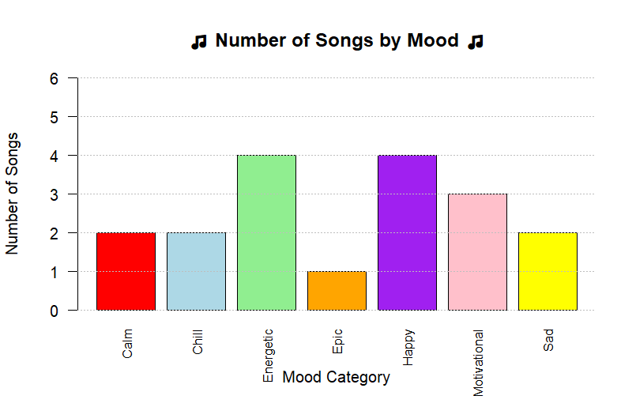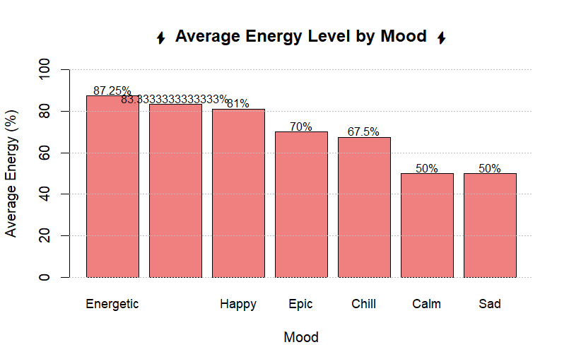
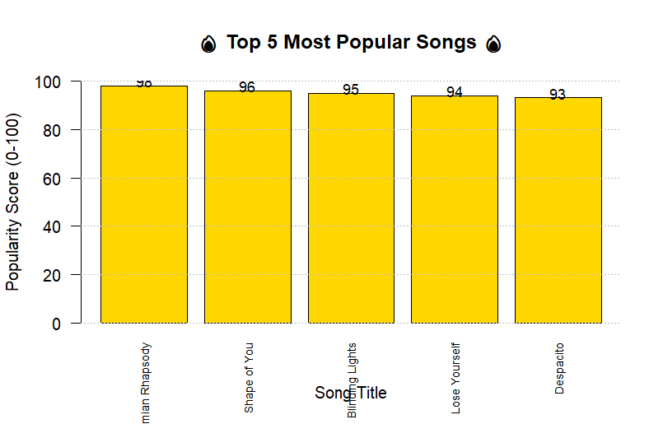

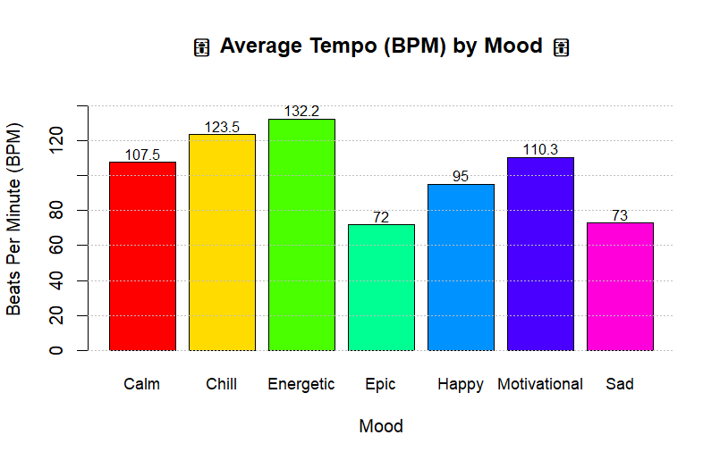

CONCLUSION

The Music Recommendation System developed in this project successfully demonstrates how data analysis and visualization can be used to solve real-world problems. The system allows users to select songs based on their mood, making music selection easier and more personalized.
The project highlights the importance of:
- Data organization
- Data analysis
- Visualization
- User interaction
Although the system is simple, it provides a strong foundation for more advanced systems such as AI-based recommendation engines used in real-world platforms.
Future improvements may include:
- Using real-time datasets
- Adding machine learning algorithms
- Creating a graphical user interface
- Integrating with music streaming APIs

LEARNING OUTCOMES

After completing this project, I will be able to:
- Understand R programming fundamentals
- Create and manipulate datasets
- Perform statistical and analytical operations
- Use functions and loops effectively
- Develop logical thinking and coding skills
- Create professional-quality visualizations
- Understand recommendation system concepts
- Handle user interaction in programs
- Apply programming to real-world applications
- Build confidence in project development

